**Simulation:**

Firstly start_stop will be equal 1 as the stop watch didn’t work yet

Output on seven segment will be zero .

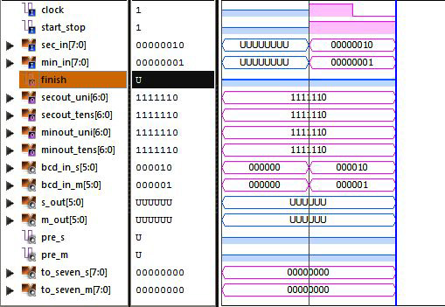

When I push the button of start_stop (force it by 0) the stop watch work and start count from the initial value of minutes and seconds which I input it before start down.

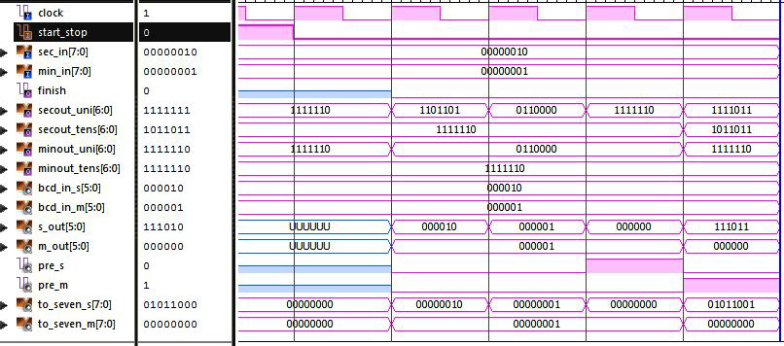

When the stop watch reach to 00:00 the output

Finish will be 1.

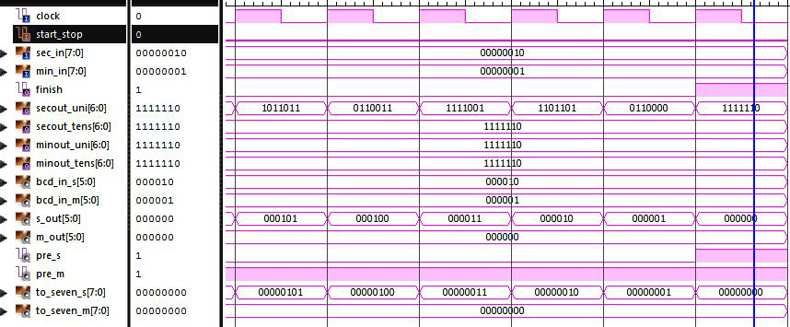If I want to stop counting any time just click on start_stop button

(force it be 1 again)

